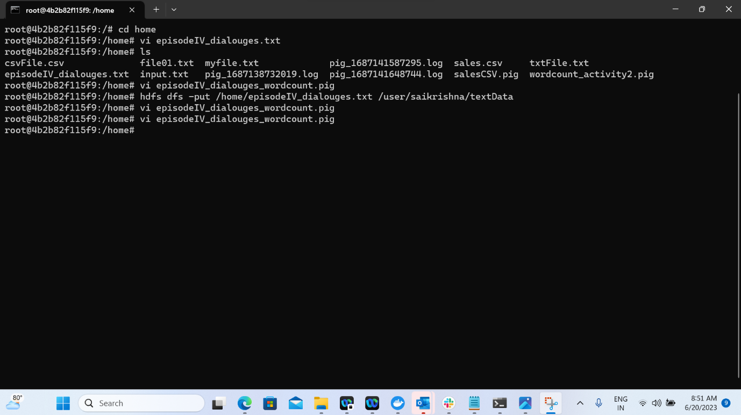

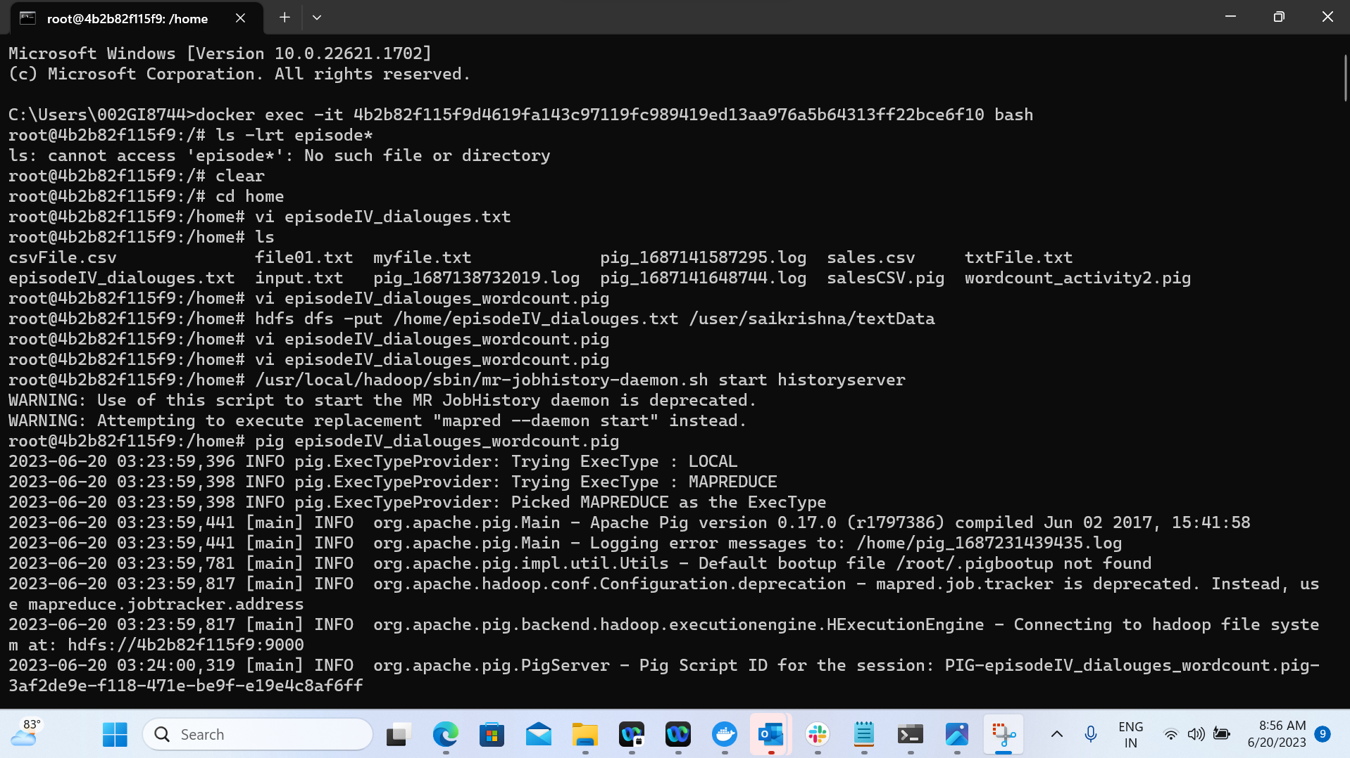

Saving copy of output file in local system

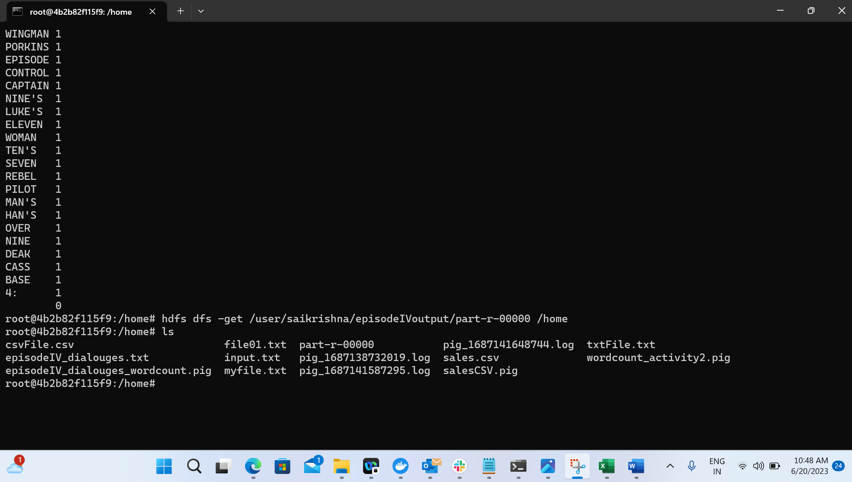

Log file



Output file

